PRACTICAL – 2A
AIM: Create a simple application to demonstrate the concepts boxing and unboxing.
CODE
using System;
using System.Collections.Generic;
using System.Linq;
using System.Text;
using System.Threading.Tasks;

namespace NewPract2_a_
{
class Program
{
static void Main(string[] args)
{
Console.WriteLine("NAME: SHEKHAR SUMAN");
Console.WriteLine("ROLL NO: 47\n");

// Boxing: Converting a value type (int) to an object
int num = 123; // Value type
object obj = num; // Boxing - num is converted to an object
obj = 145;

// Display the boxed value
Console.WriteLine("Boxing:");
Console.WriteLine($"Value type (int): {num}");
Console.WriteLine($"Boxed type (object): {obj}");

// Unboxing: Converting an object back to a value type
int unboxedNum = (int)obj; // Unboxing - obj is converted back to an int

// Display the unboxed value
Console.WriteLine("\nUnboxing:");
Console.WriteLine($"Boxed type (object): {obj}");
Console.WriteLine($"Value type (int): {num}");
Console.WriteLine($"Unboxed type (int): {unboxedNum}");

Console.ReadKey();
}
}
}
OUTPUT
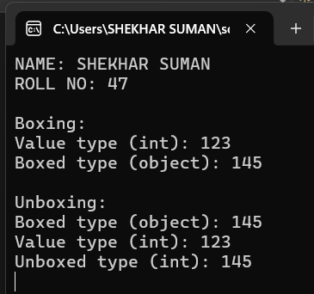

PRACTICAL – 3B
AIM: Create a simple application to demonstrate your vacation using calendar control.
CODE
using System;
using System.Web;
using System.Web.UI;
using System.Web.UI.WebControls;

namespace Practical_3
{
public partial class Pract_3bb : System.Web.UI.Page
{
protected void Page_Load(object sender, EventArgs e)
{
}

protected void Calendar1_DayRender(object sender, DayRenderEventArgs e)
{
// Mark vacation between 7th and 12th September 2025
if ((e.Day.Date >= new DateTime(2025, 09, 7)) && (e.Day.Date <= new DateTime(2025, 09, 12)))
{
e.Cell.BackColor = System.Drawing.Color.Navy;
e.Cell.BorderColor = System.Drawing.Color.Black;
e.Cell.ForeColor = System.Drawing.Color.White;
e.Cell.BorderWidth = new Unit(3);

if (e.Day.Date == new DateTime(2025, 09, 7))
{
e.Cell.Controls.Add(new LiteralControl("<br> Ganpati Vacation Start"));
}
if (e.Day.Date == new DateTime(2025, 09, 12))
{
e.Cell.Controls.Add(new LiteralControl("<br> Ganpati Vacation End"));
}
}
}

protected void Calendar1_SelectionChanged(object sender, EventArgs e)
{
if (Calendar1.SelectedDate.Date >= new DateTime(2025, 09, 7) &&
Calendar1.SelectedDate.Date <= new DateTime(2025, 09, 12))
{
Response.Write("<br><h1>Ganpati Vacation..... Go to your village and worship Lord Ganesh</h1><br>");
}
}
}
}

OUTPUT

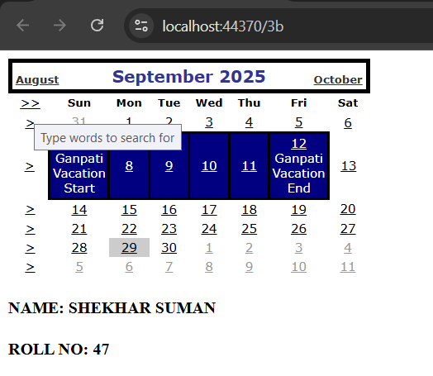

PRACTICAL – 4B
AIM: Create Web Form to demonstrate use of Adrotator Control.
Design
<%@ Page Language="C#" AutoEventWireup="true"
CodeBehind="Adrotator4b.aspx.cs"
Inherits="Pract_4_a.Adrotator4b" %>

<!DOCTYPE html>
<html xmlns="http://www.w3.org/1999/xhtml">
<head runat="server">
<title>AdRotator Example</title>
</head>
<body>
<form id="form1" runat="server">
<div>
<asp:AdRotator ID="AdRotator1" runat="server"
AdvertisementFile="~/XMLFile1.xml" />
<br />
<h4>NAME: SHEKHAR SUMAN</h4>
</div>
</form>
</body>
</html>

CODE

using System;
using System.Web.UI;

namespace Pract_4_a
{
public partial class Adrotator4b : System.Web.UI.Page
{
protected void Page_Load(object sender, EventArgs e)
{
// No custom logic needed right now
}
}
}

XML FILES
<?xml version="1.0" encoding="utf-8" ?>
<Advertisements>
<Ad>
<ImageUrl>~/Images/Coke.jpg</ImageUrl>
<Impressions>1</Impressions>
<NavigateUrl>https://www.cocacolacompany.com/</NavigateUrl>
<AlternateText>Coke image is missing</AlternateText>
<Keyword>Coke</Keyword>
</Ad>

<Ad>
<ImageUrl>~/Images/Frooti.jpg</ImageUrl>
<Impressions>5</Impressions>
<NavigateUrl>https://gdjalan.edu.in/commercefaculty-degree-college/</NavigateUrl>
<AlternateText>Frooti image is missing</AlternateText>
<Keyword>Frooti</Keyword>
</Ad>

<Ad>
<ImageUrl>~/Images/Pepsi.jpg</ImageUrl>
<Impressions>1</Impressions>
<NavigateUrl>https://www.pepsi.com/</NavigateUrl>
<AlternateText>Pepsi image is missing</AlternateText>
<Keyword>Pepsi</Keyword>
</Ad>
</Advertisements>

OUTPUT
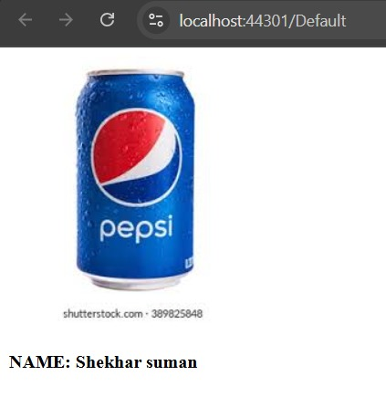

PRACTICAL – 4C
AIM: Create Web Form to demonstrate use User Controls.
Design
<%@ Page Language="C#" AutoEventWireup="true"
CodeBehind="4C.aspx.cs" Inherits="Pract_4_a._4C" %>

<%@ Register src="WebUserControl1.ascx" tagname="MyControl"
tagprefix="user" %>

<!DOCTYPE html>
<html xmlns="http://www.w3.org/1999/xhtml">
<head runat="server">
<title></title>
</head>
<body>
<form id="form1" runat="server">
<user:MyControl ID="WebUserControl11" runat="server" />
<div>
<br />
<br />
<asp:Image ID="Image1" runat="server"
ImageUrl="~/Images/nature.jpeg" />
<br />
<h4>NAME: Alister Quinny</h4>
</div>
</form>
</body>
</html>

Code
using System;
using System.Collections.Generic;
using System.Linq;
using System.Web;
using System.Web.UI;
using System.Web.UI.WebControls;

namespace Pract_4_c
{
public partial class _4C : System.Web.UI.Page
{
protected void Page_Load(object sender, EventArgs e)
{
}
}
}

OUTPUT
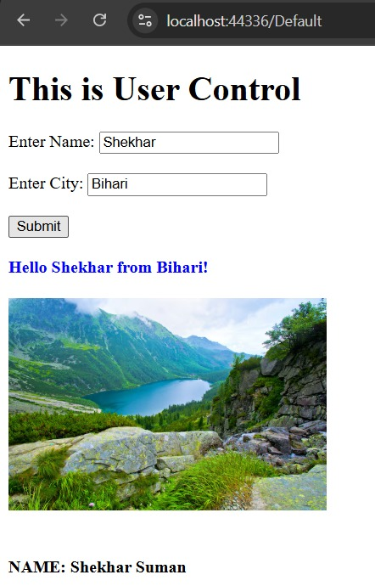
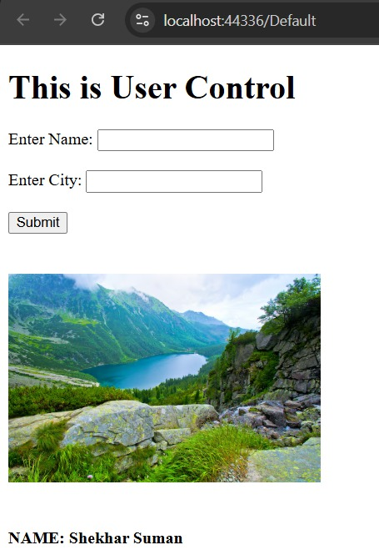

PRACTICAL – 8B
AIM: Create a web application for user defined exception handling.
Design
<%@ Page Language="C#" AutoEventWireup="true"
CodeBehind="WebForm1.aspx.cs"
Inherits="New_Pract_8_b.WebForm1" %>

<!DOCTYPE html>
<html xmlns="http://www.w3.org/1999/xhtml">
<head runat="server">
<title></title>
</head>
<body>
<form id="form1" runat="server">
<div>
<asp:Label ID="Label1" runat="server" Text=""></asp:Label>
<br />
<br />
<asp:Label ID="Label2" runat="server" Text=""></asp:Label>
</div>
</form>
</body>
</html>

CODE

using System;
using System.Collections.Generic;
using System.Linq;
using System.Web;
using System.Web.UI;
using System.Web.UI.WebControls;

namespace New_Pract_8_b
{
public partial class WebForm1 : System.Web.UI.Page
{
protected void Page_Load(object sender, EventArgs e)
{
try
{
// Throwing the custom exception
throw new UserDefinedException("New User Defined Exception");
}
catch (UserDefinedException ex) // Catching the custom exception
{
Label1.Text = "<b>Exception caught here: </b>" + ex.Message;
}
catch (Exception ex) // Catching any other exceptions
{
Label1.Text = "<b>Exception caught here: </b>" + ex.ToString();
}

// Final statement
Label2.Text = "Final Statement that is executed";
}

// Custom exception class
class UserDefinedException : Exception
{
public UserDefinedException(string message) : base(message)
{
// Optionally log the exception message or perform other actions
}
}
}
}

OUTPUT

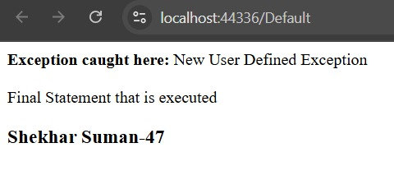

NAME: SHEKHAR SUMAN |  | INDEX
CLASS: T.Y.B.Sc.I.T. | ROLL No: 47 | INDEX
SUBJECT: ADVANCED WEB PROGRAMMING (A.W.P) |  | INDEX
COLLEGE: ST. ROCK’S DEGREE COLLEGE |  | INDEX

PR No: | TITLE | DATE | SIGN
1A | Create an application to print on screen the output of adding,  subtracting, multiplying and dividing two numbers entered by the user in C#. | 20/06/2025
1B | Create an application to print Floyd’s triangle till n rows in C#. | 11/07/02025
1C | Create an application to demonstrate following operations  - Generate Fibonacci series.  - Test for prime numbers. | 25/07/2025
2A | Create a simple application to demonstrate the concepts boxing and unboxing | 01/0/2025
3B | Create a simple application to demonstrate your vacation using calendar control. | 08/08/2025
4B | Create Web From to demonstrate use of Adrotator Control. | 22/08/2025
4C | Create Web From to demonstrate use User Controls. | 05/09/2025
8B | Create a web application for user defined exception handling. | 19/09/2025

CERTIFICATE

Class: T.Y.B.Sc.I.T. |  | Year: 2025 - 2026
This is to certify that work entered in this Journal is the work of
Shri / Kumari: SHEKHAR SUMAN .
of T.Y.B.Sc.I.T division Roll No. 47 .
Uni. Exam No. . has satisfactorily completed the
Required number of practical and worked for the 5th Semester
Of the year 2025 - 2026 in the college laboratory as laid down
By the university.

Head of the | External | Internal Examiner
Department | Examiner | Subject teacher

Date:

